Irwan Syahputra ( BE-12 )

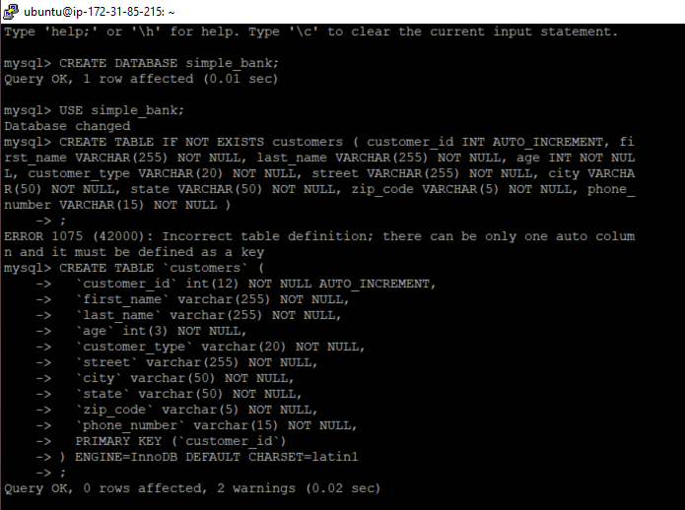

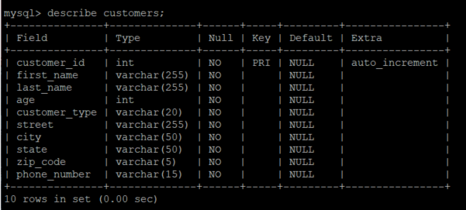

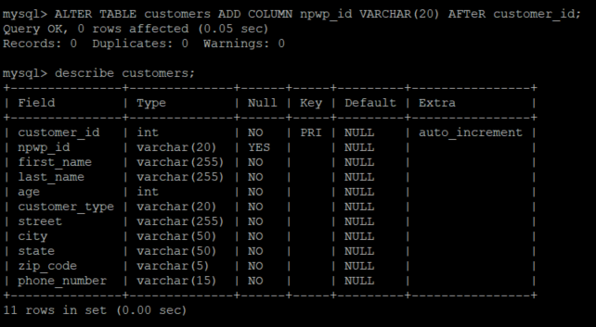

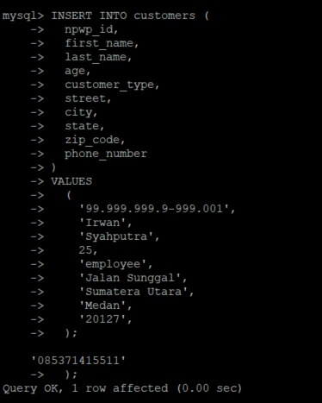

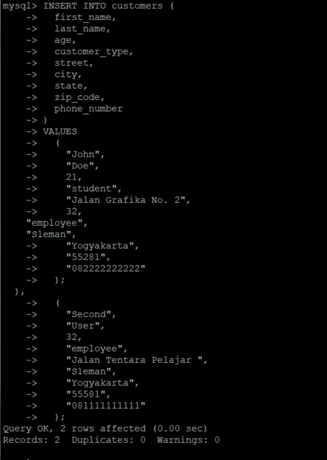

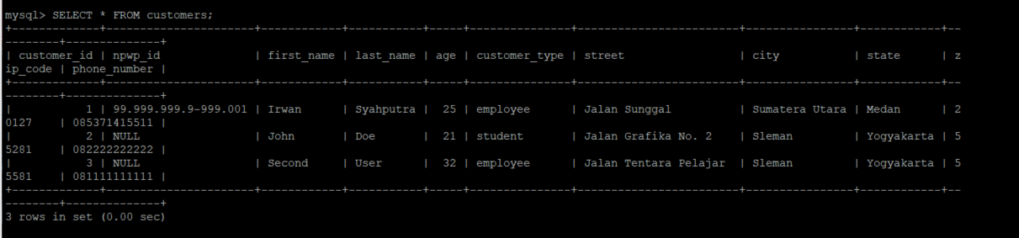

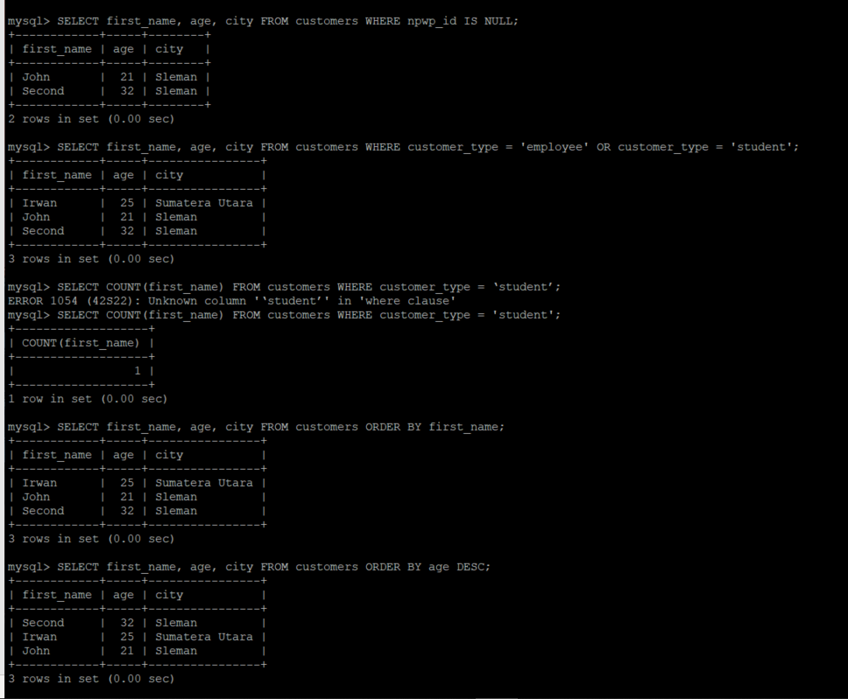

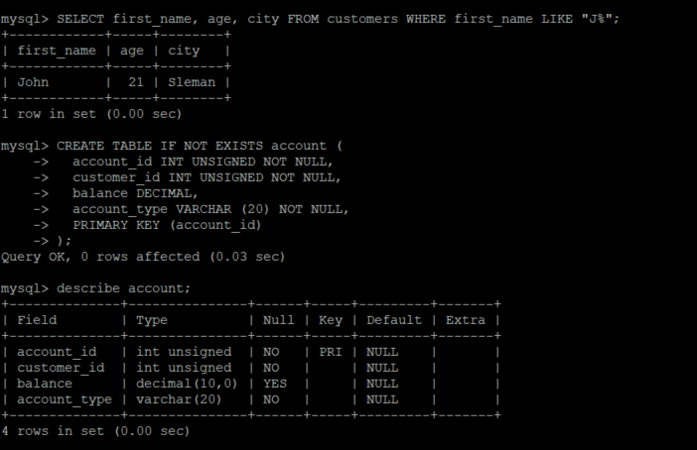

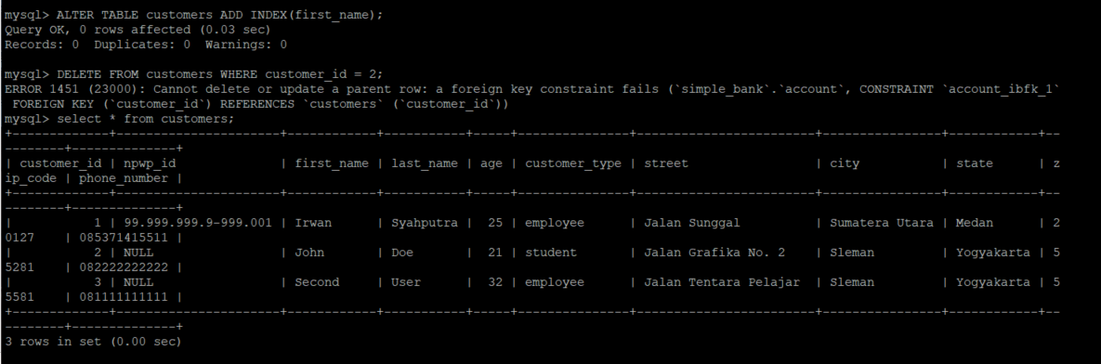

ID 2 ERROR PADA SAAT DI HAPUS KARENA ID 2 SUDAH DIGUNAKAN PADA TABEL ACCOUNT DIKARENAKAN FOREIGNKEY CHECK.

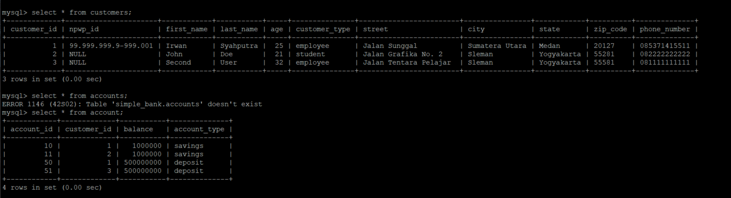

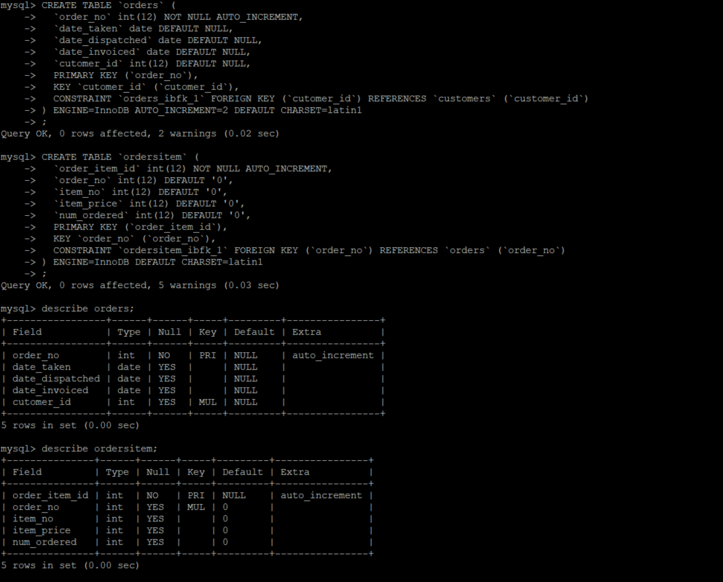

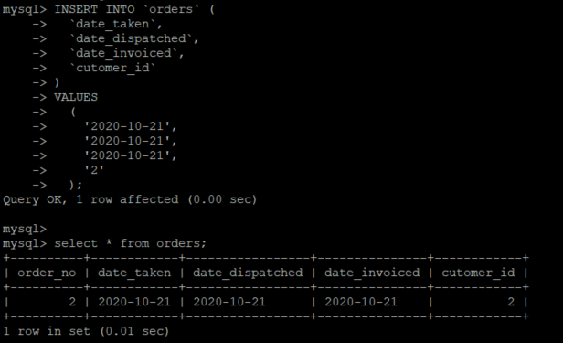

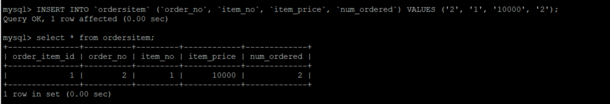

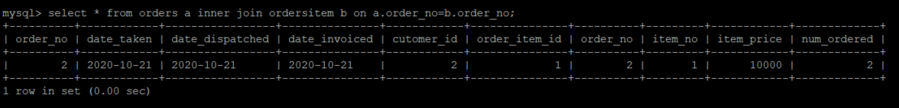

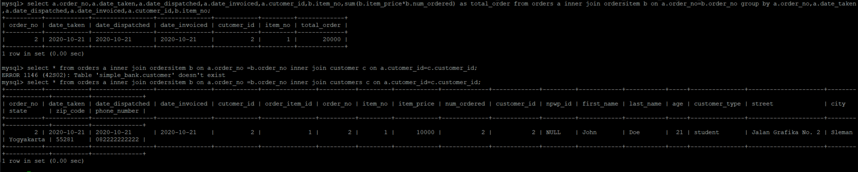

Script Display;

mysql> CREATE DATABASE simple_bank;

Query OK, 1 row affected (0.01 sec)

mysql> USE simple_bank;

Database changed

mysql> CREATE TABLE IF NOT EXISTS customers ( customer_id INT AUTO_INCREMENT, fi rst_name VARCHAR(255) NOT NULL, last_name VARCHAR(255) NOT NULL, age INT NOT NUL L, customer_type VARCHAR(20) NOT NULL, street VARCHAR(255) NOT NULL, city VARCHA R(50) NOT NULL, state VARCHAR(50) NOT NULL, zip_code VARCHAR(5) NOT NULL, phone_ number VARCHAR(15) NOT NULL )

-> ;

ERROR 1075 (42000): Incorrect table definition; there can be only one auto colum n and it must be defined as a key

mysql> CREATE TABLE `customers` (

-> `customer_id` int(12) NOT NULL AUTO_INCREMENT,

-> `first_name` varchar(255) NOT NULL,

-> `last_name` varchar(255) NOT NULL,

-> `age` int(3) NOT NULL,

-> `customer_type` varchar(20) NOT NULL,

-> `street` varchar(255) NOT NULL,

-> `city` varchar(50) NOT NULL,

-> `state` varchar(50) NOT NULL,

-> `zip_code` varchar(5) NOT NULL,

-> `phone_number` varchar(15) NOT NULL,

-> PRIMARY KEY (`customer_id`)

-> ) ENGINE=InnoDB DEFAULT CHARSET=latin1

-> ;

Query OK, 0 rows affected, 2 warnings (0.02 sec)

mysql> describe customers;

+---------------+--------------+------+-----+---------+----------------+

| Field | Type | Null | Key | Default | Extra |

+---------------+--------------+------+-----+---------+----------------+

| customer_id | int | NO | PRI | NULL | auto_increment |

| first_name | varchar(255) | NO | | NULL | |

| last_name | varchar(255) | NO | | NULL | |

| age | int | NO | | NULL | |

| customer_type | varchar(20) | NO | | NULL | |

| street | varchar(255) | NO | | NULL | |

| city | varchar(50) | NO | | NULL | |

| state | varchar(50) | NO | | NULL | |

| zip_code | varchar(5) | NO | | NULL | |

| phone_number | varchar(15) | NO | | NULL | |

+---------------+--------------+------+-----+---------+----------------+

10 rows in set (0.00 sec)

mysql> ALTER TABLE customers ADD COLUMN npwp_id VARCHAR(20) AFTeR customer_id;

Query OK, 0 rows affected (0.05 sec)

Records: 0 Duplicates: 0 Warnings: 0

mysql> describe customers;

+---------------+--------------+------+-----+---------+----------------+

| Field | Type | Null | Key | Default | Extra |

+---------------+--------------+------+-----+---------+----------------+

| customer_id | int | NO | PRI | NULL | auto_increment |

| npwp_id | varchar(20) | YES | | NULL | |

| first_name | varchar(255) | NO | | NULL | |

| last_name | varchar(255) | NO | | NULL | |

| age | int | NO | | NULL | |

| customer_type | varchar(20) | NO | | NULL | |

| street | varchar(255) | NO | | NULL | |

| city | varchar(50) | NO | | NULL | |

| state | varchar(50) | NO | | NULL | |

| zip_code | varchar(5) | NO | | NULL | |

| phone_number | varchar(15) | NO | | NULL | |

+---------------+--------------+------+-----+---------+----------------+

11 rows in set (0.00 sec)

mysql> INSERT INTO customers (

-> npwp_id,

-> first_name,

-> last_name,

-> age,

-> customer_type,

-> street,

-> city,

-> state,

-> zip_code,

-> phone_number

-> )

-> VALUES

-> (

-> '99.999.999.9-999.001',

-> 'Irwan',

-> 'Syahputra',

-> 25,

-> 'employee',

-> 'Jalan Sunggal',

-> 'Sumatera Utara',

-> 'Medan',

-> '20127',

-> );

'085371415511'

-> );

Query OK, 1 row affected (0.00 sec)

mysql>

mysql> INSERT INTO customers (

-> first_name,

-> last_name,

-> age,

-> customer_type,

-> street,

-> city,

-> state,

-> zip_code,

-> phone_number

-> )

-> VALUES

-> (

-> "John",

-> "Doe",

-> 21,

-> "student",

-> "Jalan Grafika No. 2",

-> 32,

"employee",

"Sleman",

-> "Yogyakarta",

-> "55281",

-> "082222222222"

-> );

),

-> (

-> "Second",

-> "User",

-> 32,

-> "employee",

-> "Jalan Tentara Pelajar ",

-> "Sleman",

-> "Yogyakarta",

-> "55581",

-> "081111111111"

-> );

Query OK, 2 rows affected (0.00 sec)

Records: 2 Duplicates: 0 Warnings: 0

mysql>

mysql> SELECT * FROM customers;

+-------------+----------------------+------------+-----------+-----+----------- ----+------------------------+----------------+------------+----------+--------- -----+

| customer_id | npwp_id | first_name | last_name | age | customer_t ype | street | city | state | zip_code | phone_nu mber |

+-------------+----------------------+------------+-----------+-----+----------- ----+------------------------+----------------+------------+----------+--------- -----+

| 1 | 99.999.999.9-999.001 | Irwan | Syahputra | 25 | employee | Jalan Sunggal | Sumatera Utara | Medan | 20127 | 08537141 5511 |

| 2 | NULL | John | Doe | 21 | student | Jalan Grafika No. 2 | Sleman | Yogyakarta | 55281 | 08222222 2222 |

| 3 | NULL | Second | User | 32 | employee | Jalan Tentara Pelajar | Sleman | Yogyakarta | 55581 | 08111111 1111 |

+-------------+----------------------+------------+-----------+-----+----------- ----+------------------------+----------------+------------+----------+--------- -----+

3 rows in set (0.00 sec)

mysql> SELECT * FROM customers;

+-------------+----------------------+------------+-----------+-----+---------------+------------------------+----------------+------------+-- --------+--------------+

| customer_id | npwp_id | first_name | last_name | age | customer_type | street | city | state | z ip_code | phone_number |

+-------------+----------------------+------------+-----------+-----+---------------+------------------------+----------------+------------+-- --------+--------------+

| 1 | 99.999.999.9-999.001 | Irwan | Syahputra | 25 | employee | Jalan Sunggal | Sumatera Utara | Medan | 2 0127 | 085371415511 |

| 2 | NULL | John | Doe | 21 | student | Jalan Grafika No. 2 | Sleman | Yogyakarta | 5 5281 | 082222222222 |

| 3 | NULL | Second | User | 32 | employee | Jalan Tentara Pelajar | Sleman | Yogyakarta | 5 5581 | 081111111111 |

+-------------+----------------------+------------+-----------+-----+---------------+------------------------+----------------+------------+-- --------+--------------+

3 rows in set (0.00 sec)

mysql> SELECT first_name, age, city FROM customers WHERE npwp_id IS NULL;

+------------+-----+--------+

| first_name | age | city |

+------------+-----+--------+

| John | 21 | Sleman |

| Second | 32 | Sleman |

+------------+-----+--------+

2 rows in set (0.00 sec)

mysql> SELECT first_name, age, city FROM customers WHERE customer_type = 'employee' OR customer_type = 'student';

+------------+-----+----------------+

| first_name | age | city |

+------------+-----+----------------+

| Irwan | 25 | Sumatera Utara |

| John | 21 | Sleman |

| Second | 32 | Sleman |

+------------+-----+----------------+

3 rows in set (0.00 sec)

mysql> SELECT COUNT(first_name) FROM customers WHERE customer_type = ‘student’;

ERROR 1054 (42S22): Unknown column '‘student’' in 'where clause'

mysql> SELECT COUNT(first_name) FROM customers WHERE customer_type = 'student';

+-------------------+

| COUNT(first_name) |

+-------------------+

| 1 |

+-------------------+

1 row in set (0.00 sec)

mysql> SELECT first_name, age, city FROM customers ORDER BY first_name;

+------------+-----+----------------+

| first_name | age | city |

+------------+-----+----------------+

| Irwan | 25 | Sumatera Utara |

| John | 21 | Sleman |

| Second | 32 | Sleman |

+------------+-----+----------------+

3 rows in set (0.00 sec)

mysql> SELECT first_name, age, city FROM customers ORDER BY age DESC;

+------------+-----+----------------+

| first_name | age | city |

+------------+-----+----------------+

| Second | 32 | Sleman |

| Irwan | 25 | Sumatera Utara |

| John | 21 | Sleman |

+------------+-----+----------------+

3 rows in set (0.00 sec)

mysql> SELECT first_name, age, city FROM customers WHERE first_name LIKE "J%";

+------------+-----+--------+

| first_name | age | city |

+------------+-----+--------+

| John | 21 | Sleman |

+------------+-----+--------+

1 row in set (0.00 sec)

mysql> CREATE TABLE IF NOT EXISTS account (

-> account_id INT UNSIGNED NOT NULL,

-> customer_id INT UNSIGNED NOT NULL,

-> balance DECIMAL,

-> account_type VARCHAR (20) NOT NULL,

-> PRIMARY KEY (account_id)

-> );

Query OK, 0 rows affected (0.03 sec)

mysql> describe account;

+--------------+---------------+------+-----+---------+-------+

| Field | Type | Null | Key | Default | Extra |

+--------------+---------------+------+-----+---------+-------+

| account_id | int unsigned | NO | PRI | NULL | |

| customer_id | int unsigned | NO | | NULL | |

| balance | decimal(10,0) | YES | | NULL | |

| account_type | varchar(20) | NO | | NULL | |

+--------------+---------------+------+-----+---------+-------+

4 rows in set (0.00 sec)

mysql> ALTER TABLE `simple_bank`.`account` CHANGE `customer_id` `customer_id` INT(10) NOT NULL, ADD FOREIGN KEY (`customer_id`) REFERENCES `si mple_bank`.`customers`(`customer_id`);

Query OK, 0 rows affected, 1 warning (0.05 sec)

Records: 0 Duplicates: 0 Warnings: 1

mysql> ALTER TABLE `simple_bank`.`account` ADD FOREIGN KEY (`customer_id`) REFERENCES `simple_bank`.`customers`(`customer_id`);

Query OK, 0 rows affected (0.05 sec)

Records: 0 Duplicates: 0 Warnings: 0

mysql> describe account;

+--------------+---------------+------+-----+---------+-------+

| Field | Type | Null | Key | Default | Extra |

+--------------+---------------+------+-----+---------+-------+

| account_id | int unsigned | NO | PRI | NULL | |

| customer_id | int | NO | MUL | NULL | |

| balance | decimal(10,0) | YES | | NULL | |

| account_type | varchar(20) | NO | | NULL | |

+--------------+---------------+------+-----+---------+-------+

4 rows in set (0.00 sec)

mysql> INSERT INTO account(account_id, customer_id, balance, account_type) VALUES (10, 1, 1000000, 'savings'), (50, 1, 500000000, 'deposit'), (11, 2, 1000000, 'savings'), (51, 3, 500000000, 'deposit');

Query OK, 4 rows affected (0.01 sec)

Records: 4 Duplicates: 0 Warnings: 0

mysql> SELECT cust.first_name, acc.balance, acc.account_type FROM customers cust, account acc WHERE cust.customer_id = acc.customer_id;

+------------+-----------+--------------+

| first_name | balance | account_type |

+------------+-----------+--------------+

| Irwan | 1000000 | savings |

| Irwan | 500000000 | deposit |

| John | 1000000 | savings |

| Second | 500000000 | deposit |

+------------+-----------+--------------+

4 rows in set (0.00 sec)

mysql> SELECT customer_id, COUNT(account_id) as no_of_acc FROM account GROUP BY (customer_id);

+-------------+-----------+

| customer_id | no_of_acc |

+-------------+-----------+

| 1 | 2 |

| 2 | 1 |

| 3 | 1 |

+-------------+-----------+

3 rows in set (0.00 sec)

mysql> ALTER TABLE customers ADD INDEX(first_name);

Query OK, 0 rows affected (0.03 sec)

Records: 0 Duplicates: 0 Warnings: 0

mysql> DELETE FROM customers WHERE customer_id = 2;

ERROR 1451 (23000): Cannot delete or update a parent row: a foreign key constraint fails (`simple_bank`.`account`, CONSTRAINT `account_ibfk_1` FOREIGN KEY (`customer_id`) REFERENCES `customers` (`customer_id`))

mysql> select * from customers;

+-------------+----------------------+------------+-----------+-----+---------------+------------------------+----------------+------------+-- --------+--------------+

| customer_id | npwp_id | first_name | last_name | age | customer_type | street | city | state | z ip_code | phone_number |

+-------------+----------------------+------------+-----------+-----+---------------+------------------------+----------------+------------+-- --------+--------------+

| 1 | 99.999.999.9-999.001 | Irwan | Syahputra | 25 | employee | Jalan Sunggal | Sumatera Utara | Medan | 2 0127 | 085371415511 |

| 2 | NULL | John | Doe | 21 | student | Jalan Grafika No. 2 | Sleman | Yogyakarta | 5 5281 | 082222222222 |

| 3 | NULL | Second | User | 32 | employee | Jalan Tentara Pelajar | Sleman | Yogyakarta | 5 5581 | 081111111111 |

+-------------+----------------------+------------+-----------+-----+---------------+------------------------+----------------+------------+-- --------+--------------+

3 rows in set (0.00 sec)

mysql> select * from customers;

+-------------+----------------------+------------+-----------+-----+---------------+------------------------+----------------+------------+----------+--------------+

| customer_id | npwp_id | first_name | last_name | age | customer_type | street | city | state | zip_code | phone_number |

+-------------+----------------------+------------+-----------+-----+---------------+------------------------+----------------+------------+----------+--------------+

| 1 | 99.999.999.9-999.001 | Irwan | Syahputra | 25 | employee | Jalan Sunggal | Sumatera Utara | Medan | 20127 | 085371415511 |

| 2 | NULL | John | Doe | 21 | student | Jalan Grafika No. 2 | Sleman | Yogyakarta | 55281 | 082222222222 |

| 3 | NULL | Second | User | 32 | employee | Jalan Tentara Pelajar | Sleman | Yogyakarta | 55581 | 081111111111 |

+-------------+----------------------+------------+-----------+-----+---------------+------------------------+----------------+------------+----------+--------------+

3 rows in set (0.00 sec)

mysql> select * from accounts;

ERROR 1146 (42S02): Table 'simple_bank.accounts' doesn't exist

mysql> select * from account;

+------------+-------------+-----------+--------------+

| account_id | customer_id | balance | account_type |

+------------+-------------+-----------+--------------+

| 10 | 1 | 1000000 | savings |

| 11 | 2 | 1000000 | savings |

| 50 | 1 | 500000000 | deposit |

| 51 | 3 | 500000000 | deposit |

+------------+-------------+-----------+--------------+

4 rows in set (0.00 sec)

mysql> INSERT INTO `orders` (

-> `date_taken`,

-> `date_dispatched`,

-> `date_invoiced`,

-> `cutomer_id`

-> )

-> VALUES

-> (

-> '2020-10-21',

-> '2020-10-21',

-> '2020-10-21',

-> '2'

-> );

Query OK, 1 row affected (0.00 sec)

mysql>

mysql> select * from orders;

+----------+------------+-----------------+---------------+------------+

| order_no | date_taken | date_dispatched | date_invoiced | cutomer_id |

+----------+------------+-----------------+---------------+------------+

| 2 | 2020-10-21 | 2020-10-21 | 2020-10-21 | 2 |

+----------+------------+-----------------+---------------+------------+

1 row in set (0.01 sec)

mysql> INSERT INTO `ordersitem` (`order_no`, `item_no`, `item_price`, `num_ordered`) VALUES ('2', '1', '10000', '2');

Query OK, 1 row affected (0.00 sec)

mysql> select * from ordersitem;

+---------------+----------+---------+------------+-------------+

| order_item_id | order_no | item_no | item_price | num_ordered |

+---------------+----------+---------+------------+-------------+

| 1 | 2 | 1 | 10000 | 2 |

+---------------+----------+---------+------------+-------------+

1 row in set (0.00 sec)

mysql> select * from orders a inner join ordersitem b on a.order_no=b.order_no;

+----------+------------+-----------------+---------------+------------+---------------+----------+---------+------------+-------------+

| order_no | date_taken | date_dispatched | date_invoiced | cutomer_id | order_item_id | order_no | item_no | item_price | num_ordered |

+----------+------------+-----------------+---------------+------------+---------------+----------+---------+------------+-------------+

| 2 | 2020-10-21 | 2020-10-21 | 2020-10-21 | 2 | 1 | 2 | 1 | 10000 | 2 |

+----------+------------+-----------------+---------------+------------+---------------+----------+---------+------------+-------------+

1 row in set (0.00 sec)

mysql> select a.order_no,a.date_taken,a.date_dispatched,a.date_invoiced,a.customer_id,b.item_no,sum(b.item_price*b.num_ordered) as total_order from orders a inner join ordersitem b on a.order_no=b.order_no group by order_no,customer_id;

ERROR 1054 (42S22): Unknown column 'a.customer_id' in 'field list'

mysql> select a.order_no,a.date_taken,a.date_dispatched,a.date_invoiced,a.cutomer_id,b.item_no,sum(b.item_price*b.num_ordered) as total_order from orders a inner join ordersitem b on a.order_no=b.order_no group by order_no,customer_id;

ERROR 1054 (42S22): Unknown column 'customer_id' in 'group statement'

mysql> select a.order_no,a.date_taken,a.date_dispatched,a.date_invoiced,a.cutomer_id,b.item_no,sum(b.item_price*b.num_ordered) as total_order from orders a inner join ordersitem b on a.order_no=b.order_no group by order_no,cutomer_id;

ERROR 1055 (42000): Expression #6 of SELECT list is not in GROUP BY clause and contains nonaggregated column 'simple_bank.b.item_no' which is not functionally dependent on columns in GROUP BY clause; this is incompatible with sql_mode=only_full_group_by

mysql> select a.order_no,a.date_taken,a.date_dispatched,a.date_invoiced,a.cutomer_id,b.item_no,sum(b.item_price*b.num_ordered) as total_order from orders a inner join ordersitem b on a.order_no=b.order_no

-> ;

ERROR 1140 (42000): In aggregated query without GROUP BY, expression #1 of SELECT list contains nonaggregated column 'simple_bank.a.order_no'; this is incompatible with sql_mode=only_full_group_by

mysql> select a.order_no,a.date_taken,a.date_dispatched,a.date_invoiced,a.cutomer_id,b.item_no,sum(b.item_price*b.num_ordered) as total_order from orders a inner join ordersitem b on a.order_no=b.order_no group by a.order_no,a.date_taken,a.date_dispatched,a.date_invoiced,a.cutomer_id,b.item_no;

+----------+------------+-----------------+---------------+------------+---------+-------------+

| order_no | date_taken | date_dispatched | date_invoiced | cutomer_id | item_no | total_order |

+----------+------------+-----------------+---------------+------------+---------+-------------+

| 2 | 2020-10-21 | 2020-10-21 | 2020-10-21 | 2 | 1 | 20000 |

+----------+------------+-----------------+---------------+------------+---------+-------------+

1 row in set (0.00 sec)

mysql> select * from orders a inner join ordersitem b on a.order_no =b.order_no inner join customer c on a.cutomer_id=c.customer_id;

ERROR 1146 (42S02): Table 'simple_bank.customer' doesn't exist

mysql> select * from orders a inner join ordersitem b on a.order_no =b.order_no inner join customers c on a.cutomer_id=c.customer_id;

+----------+------------+-----------------+---------------+------------+---------------+----------+---------+------------+-------------+-------------+---------+------------+-----------+-----+---------------+---------------------+--------+------------+----------+--------------+

| order_no | date_taken | date_dispatched | date_invoiced | cutomer_id | order_item_id | order_no | item_no | item_price | num_ordered | customer_id | npwp_id | first_name | last_name | age | customer_type | street | city | state | zip_code | phone_number |

+----------+------------+-----------------+---------------+------------+---------------+----------+---------+------------+-------------+-------------+---------+------------+-----------+-----+---------------+---------------------+--------+------------+----------+--------------+

| 2 | 2020-10-21 | 2020-10-21 | 2020-10-21 | 2 | 1 | 2 | 1 | 10000 | 2 | 2 | NULL | John | Doe | 21 | student | Jalan Grafika No. 2 | Sleman | Yogyakarta | 55281 | 082222222222 |

+----------+------------+-----------------+---------------+------------+---------------+----------+---------+------------+-------------+-------------+---------+------------+-----------+-----+---------------+---------------------+--------+------------+----------+--------------+

1 row in set (0.00 sec)